CHECK OUT MIAMI

Miami is the heart of South Florida. Famous for the miles of beach and all night parties, there’s something going on 24/7. Hitting the beach is a given during a stay in the Magic City, but there are plenty of other things to experience when visiting Miami.

(MARKET IMAGE HERE)

Find Deals From These Cities

INSERT FARE GRID FROM / TO Version (if available!)

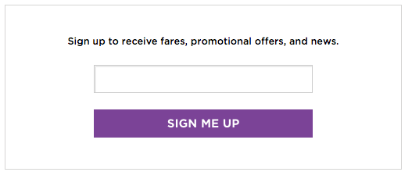   
Top Things To Do in Miami

Be sure to check out some of the options below between sunbathing and taking a dip in the water.

* Experience a taste of Cuba in Miami’s Little Havana.
* Trips to Miami aren’t complete without a little taste of South Beach. From the Art Deco architecture to the world-class boutiques and of course the crystal white sand, “SoBe” is the place to be.
* Enjoy the coffee shops, lounges, boutiques and more that make up Lincoln Road Mall (commonly referred to as “Lincoln”).
* Take in the wonderful floral smells and beautiful scenery at the free Miami Beach Botanical Garden. You can also shop for local produce and other treats at the weekly farmers’ market, or if you need some grounding, sign up for a yoga class on the peaceful grounds.

Travel Tips and Resources

[Must-Dos in Miamihttp://travel.nationalgeographic.com/travel/city-guides/miami-must-dos](http://travel.nationalgeographic.com/travel/city-guides/miami-must-dos)

[Miami Hotelshttp://www.tripadvisor.com/Hotels-g34438-Miami_Florida-Hotels.html](http://www.tripadvisor.com/Hotels-g34438-Miami_Florida-Hotels.html)

[Miami Restaurantshttp://www.tripadvisor.com/Restaurants-g34438-Miami_Florida.html](http://www.tripadvisor.com/Restaurants-g34438-Miami_Florida.html)

[Miami Shopping Guidehttp://www.timeout.com/miami/shopping/miami-shopping-best-stores-and-boutiques](http://www.timeout.com/miami/shopping/miami-shopping-best-stores-and-boutiques)

[Miami Nightlife and Entertainmenthttp://www.miamiandbeaches.com/things-to-do/nightlife](http://www.miamiandbeaches.com/things-to-do/nightlife)

[Miami Travel Tipshttp://www.travelandleisure.com/travel-guide/miami](http://www.travelandleisure.com/travel-guide/miami)

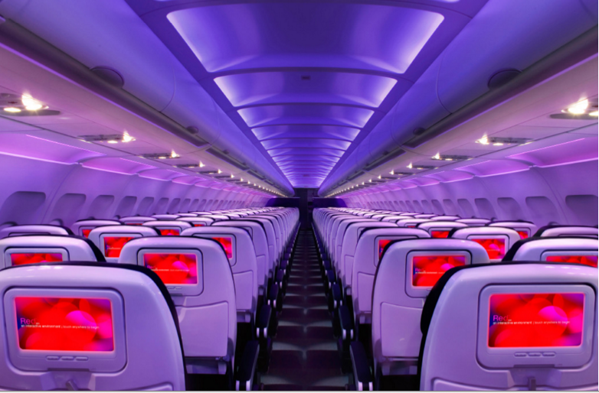

Main Cabin Main Cabin Select First Class

(add links to Cabin Class Pages)

Ready. Set. Fly.

Book your Mood-lit Ride to Miami.

Looking for alternatives to direct flights to Miami? Consider booking a Virgin America flight to Fort Lauderdale-Hollywood International Airport and then taking a scenic drive to Miami. We’re certain our custom-designed leather seats will be the most comfortable you’ve ever flown in and that you’ll be able to truly relax in the atmosphere created by our mood-lit cabins.

Take a Virtual Tour

Add Terms & Conditions